**Supplementary Figures & Tables**

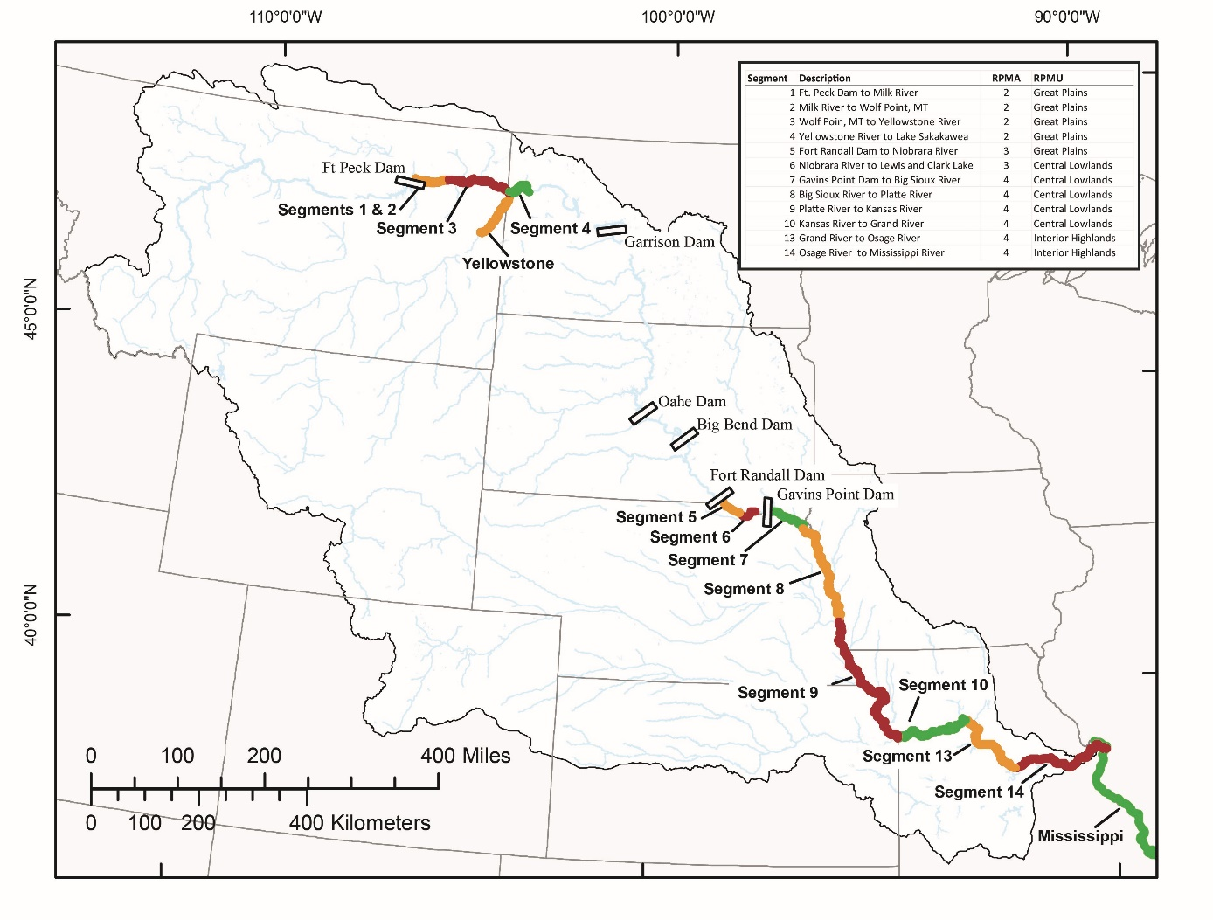

Figure 1. Map of the Missouri River highlighting regions important for PSPAP sampling, i.e., segments of the upper and lower basins, as well as relevant sections of the Yellowstone and Mississippi Rivers. Relationships between segments, recovery priority management areas (RPMA’s), and recovery plan management units (RPMU’s) are indicated in the upper right. Simulations for recruitment detection and abundance and trend estimation included sampling bends within segments 2-4 of the upper basin and segments 7-10, 13, and 14 of the lower basin under various monitoring designs.

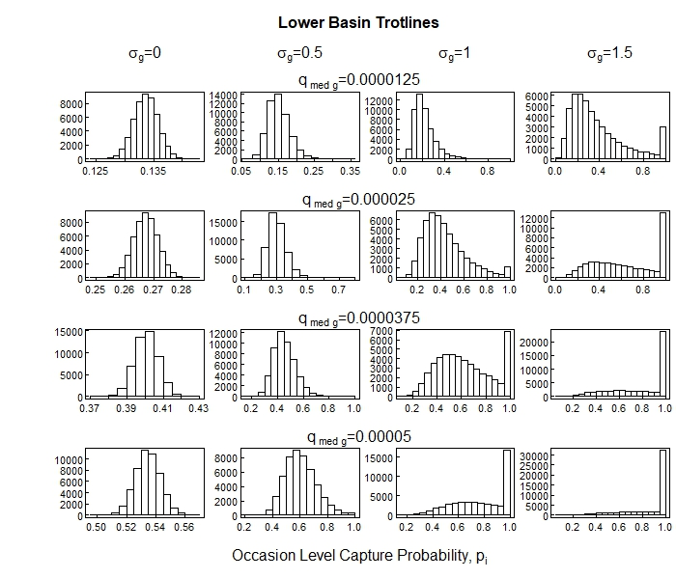

Figure 2. Occasion-level capture probability distributions simulated for trotlines in the Lower Missouri River basin for 4 values of median catchability,  paired with each of 4 levels of variation. Catchability variation is described in terms of the associated logit-normal standard deviation,  (equation 2), whose values are given at the top of each column.

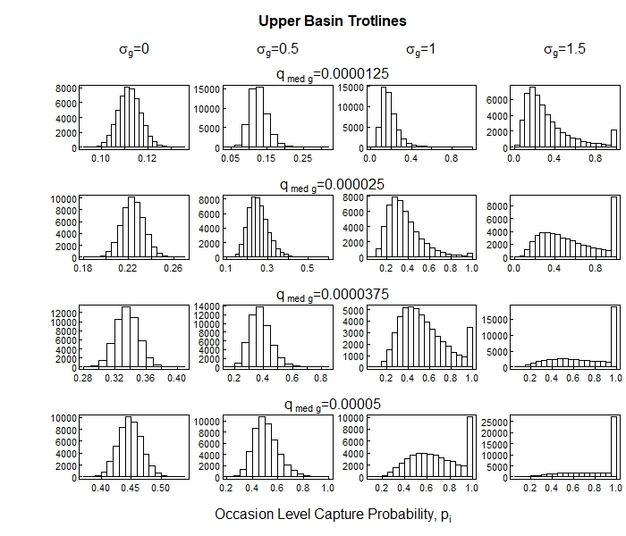

Figure 3. Occasion-level capture probability distributions simulated for trotlines in the Upper Missouri River basin for 4 values of median catchability,  paired with each of 4 levels of variation. Catchability variation is described in terms of the associated logit-normal standard deviation,  (equation 2), whose values are given at the top of each column.

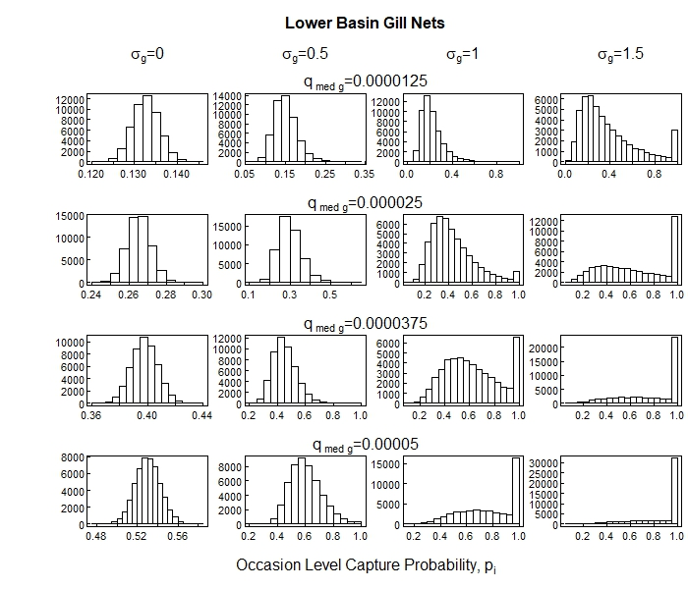

Figure 4. Occasion-level capture probability distributions simulated for gill nets in the Lower Missouri River basin for 4 values of median catchability,  paired with each of 4 levels of variation. Catchability variation is described in terms of the associated logit-normal standard deviation,  (equation 2), whose values are given at the top of each column.

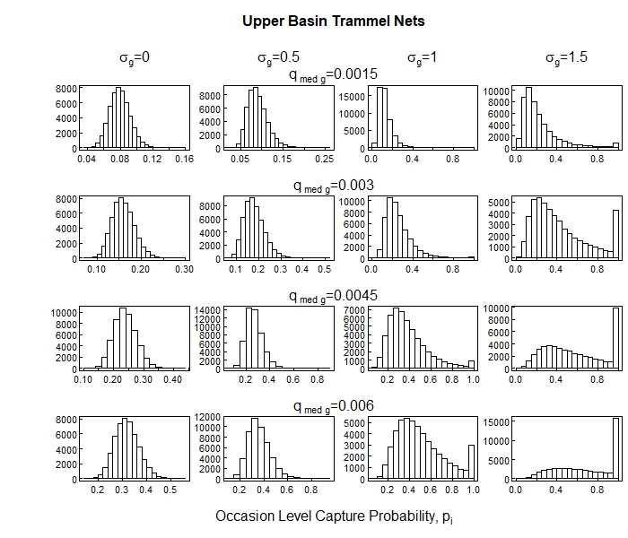

Figure 5. Occasion-level capture probability distributions simulated for trammel nets in the Upper Missouri River basin for 4 values of median catchability,  paired with each of 4 levels of variation. Catchability variation is described in terms of the associated logit-normal standard deviation,  (equation 2), whose values are given at the top of each column. Resulting occasion level probability (p_occ) distributions are similar to the previous 4, despite the change in the range of median catchability values (up to 0.006 versus 0.00005).

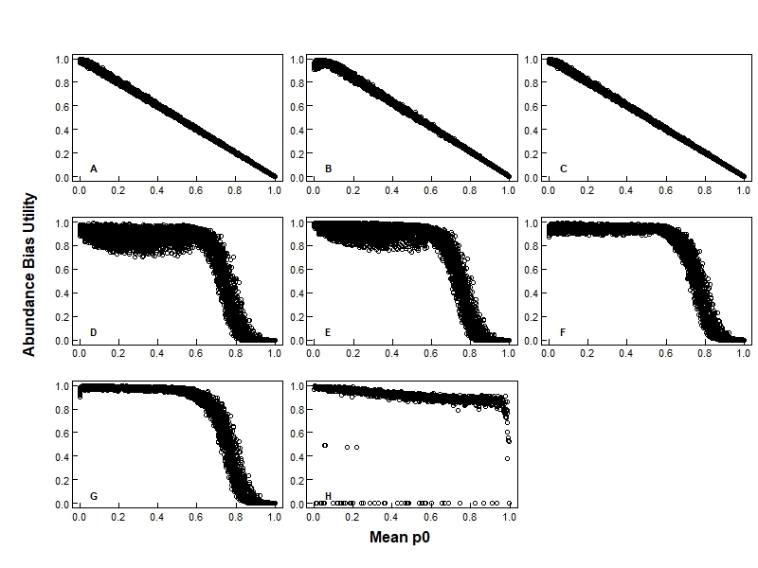

Figure 6: Abundance bias utility calculated from the catch-data simulations for trotlines (TLC1) versus  for each estimator decision. The bias utility of the basin-level abundance estimates were calculated for the following abundance estimators: minimum known alive with weighted mean aggregation (CPUE estimator package; Panel A), minimum known alive with arithmetic mean aggregation (MKA_AM; Panel B), minimum known alive with weighted mean aggregation (MKA_WM; Panel C), M0 with arithmetic mean aggregation (M0_AM; Panel D), M0 with weighted mean aggregation (M0_WM; Panel E), Mt with arithmetic mean aggregation (Mt_AM; Panel F), Mt with weighted mean aggregation (Mt_WM; Panel G), multi-state robust design (CRDMS; Panel H).

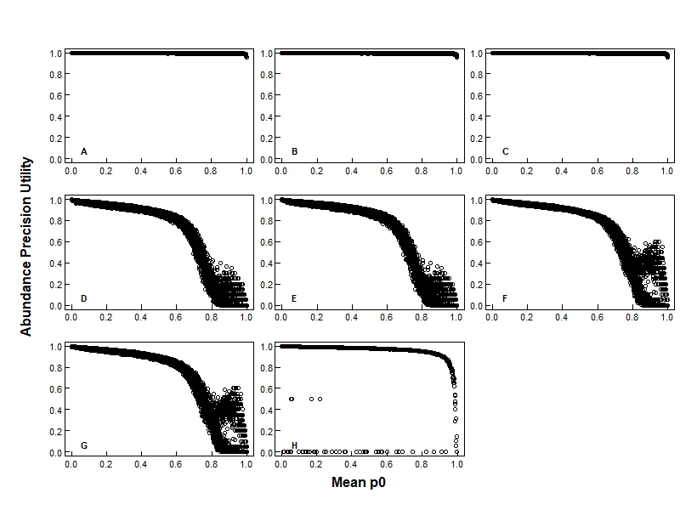

Figure 7: Abundance precision utility, as calculated from the catch-data simulations for trotlines (TLC1), and its relationship to mean  for each estimator decision. Plot labels in the bottom left hand corner distinguish the estimator package being considered (table 2). The precision utility of the basin-level abundance estimates were calculated for the following abundance estimators: **A**. minimum known alive with weighted mean aggregation (CPUE estimator package) **B**. minimum known alive with arithmetic mean aggregation (MKA_AM), **C**. minimum known alive with weighted mean aggregation (MKA_WM), **D**. M0 with arithmetic mean aggregation (M0_AM), **E**. M0 with weighted mean aggregation (M0_WM), **F**. Mt with arithmetic mean aggregation (Mt_AM), **G**. Mt with weighted mean aggregation (Mt_WM), **H**. multi-state robust design (CRDMS). The large range of abundance precision utility values seen at high mean values in plots **D**-**G** can be explained by an added affect of the number of secondary occasions, where a lower number of secondary occasions tends to result in higher abundance precision utility values for this range of .

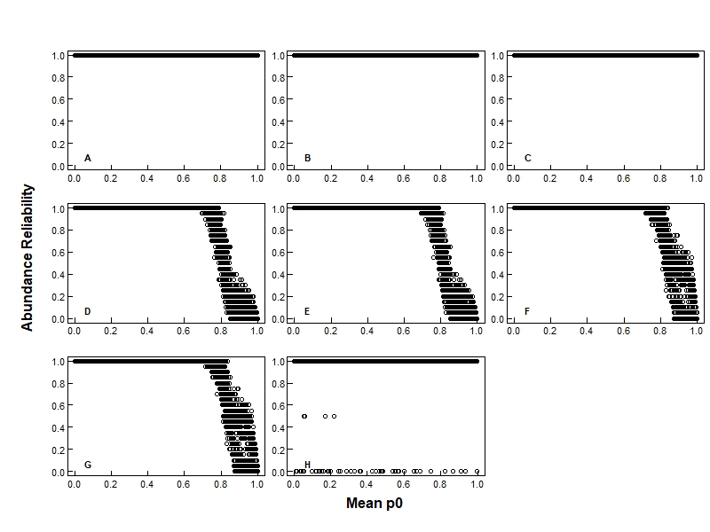

Figure 8: Abundance reliability, as calculated from the catch-data simulations for trotlines (TLC1), and its relationship to mean  for each estimator decision. Plot labels in the bottom left hand corner distinguish the estimator package being considered (table 2). Reliability of the segment-level abundance estimates were calculated for the following abundance estimators: **A**. minimum known alive with weighted mean aggregation (CPUE estimator package) **B**. minimum known alive with arithmetic mean aggregation (MKA_AM), **C**. minimum known alive with weighted mean aggregation (MKA_WM), **D**. M0 with arithmetic mean aggregation (M0_AM), **E**. M0 with weighted mean aggregation (M0_WM), **F**. Mt with arithmetic mean aggregation (Mt_AM), **G**. Mt with weighted mean aggregation (Mt_WM), **H**. multi-state robust design (CRDMS).

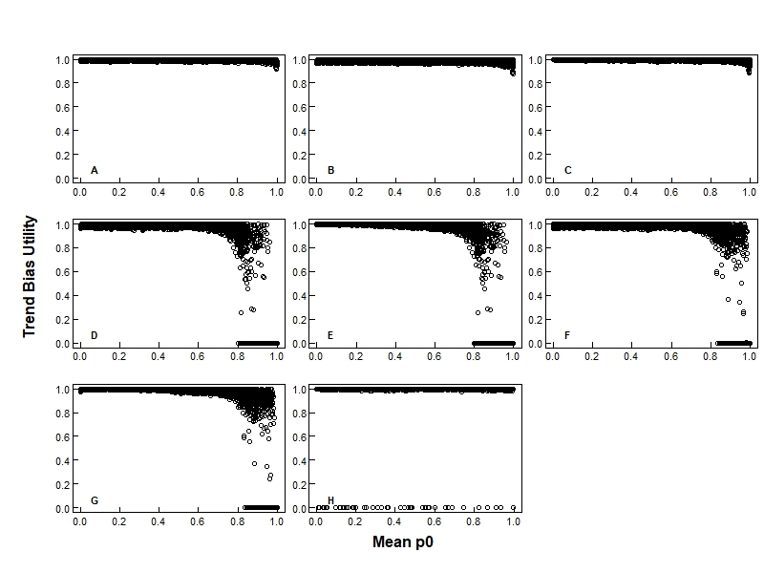

Figure 9: Trend bias utility, as calculated from the catch-data simulations for trotlines (TLC1), and its relationship to mean  for each estimator decision. Plot labels in the bottom left hand corner distinguish the packaged estimator choices (table 2). Plot **A** uses the catch-effort based trend estimator (CPUE), while plots **B**-**H** use the abundance based trend estimation method, where segment-level abundance estimates were provided by the following abundance estimators: **B**. minimum known alive with arithmetic mean aggregation (MKA_AM), **C**. minimum known alive with weighted mean aggregation (MKA_WM), **D**. M0 with arithmetic mean aggregation (M0_AM), **E**. M0 with weighted mean aggregation (M0_WM), **F**. Mt with arithmetic mean aggregation (Mt_AM), **G**. Mt with weighted mean aggregation (Mt_WM), **H**. multi-state robust design (CRDMS).

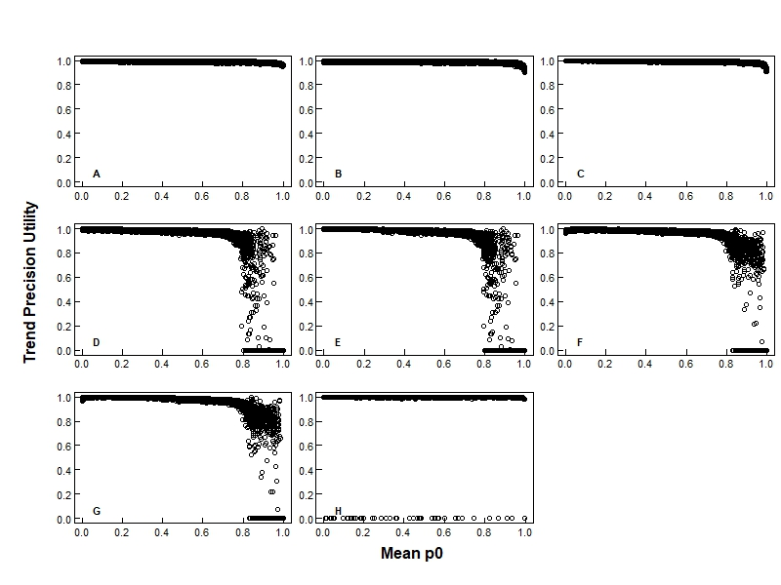

Figure 10: Trend precision utility, as calculated from the catch-data simulations for trotlines (TLC1), and its relationship to mean  for each estimator decision. Plot labels in the bottom left hand corner distinguish the packaged estimator choice (table 2). Plot **A** uses the catch-effort based trend estimator (CPUE), while Plots **B**-**H** use the abundance based trend estimation method, where segment-level abundance estimates were provided by the following abundance estimators: **B**. minimum known alive with arithmetic mean aggregation (MKA_AM), **C**. minimum known alive with weighted mean aggregation (MKA_WM), **D**. M0 with arithmetic mean aggregation (M0_AM), **E**. M0 with weighted mean aggregation (M0_WM), **F**. Mt with arithmetic mean aggregation (Mt_AM), **G**. Mt with weighted mean aggregation (Mt_WM), **H**. multi-state robust design (CRDMS).

Table 1. Median effort in minutes per deployment, and shape and rate values used to generate sampling effort data by gear and basin. Median deployment times were minded from the PSPAP database and do not include the time needed to prepare for the deployment or to record the collection data. Rate and shape values were determined by fitting a gamma distribution to effort data mined from the PSPAP database.

|  |  |  |  |  |  |
| --- | --- | --- | --- | --- | --- |
| **Basin** | **Gear** | **Gear Code** | **Median Effort** | **Shape** | **Rate** |
| Upper Basin | Trotline | TLC1 | 1119 | 65.33 | 0.0583 |
|  | Trammel Net | TN | 6 | 5.128 | 0.7735 |
| Lower Basin | Trotline | TLC1 | 1341 | 500.7 | 0.3746 |
|  | Gill Net | GN14 | 1333 | 224.5 | 0.1692 |

Table 2. The abundance and trend estimators associated with each package of the Estimator decision node.

|  |  |  |  |  |  |
| --- | --- | --- | --- | --- | --- |
| **Trend estimator** | **Abundance estimator** |  | **Scale of abundance estimator** | **Bend-level to segment-level aggregation method** | **Estimator package code** |
| Catch-effort based | Minimum Known Alive |  | Bend | Weighted Mean | CPUE |
| Abundance based | Minimum Known Alive |  | Bend | Arithmetic Mean | MKA_AM |
|  | Weighted Mean | MKA_WM |
| M0 |  | Bend | Arithmetic Mean | M0_AM |
|  | Weighted Mean | M0_WM |
| Mt |  | Bend | Arithmetic Mean | Mt_AM |
|  | Weighted Mean | Mt_WM |
| Multi-state Robust Design |  | Segment | N/A | CRDMS |

Table 3. Description of the states of the Basin nature node.

|  |  |  |  |
| --- | --- | --- | --- |
| ***Basin*** | | | |
| **States** | **Definitions** |  | **Justifications** |
| Lower | Upper Missouri River from Fort Peck Dam to the headwaters of Lake Sakakawea, including the Lower Yellowstone River up to the Intake Diversion Dam (segments 7-10,13, & 14) |  | Current PSPAP sampling region |
| Upper | Lower Missouri River from Gavins Point Dam to the confluence with the Mississippi River (segments 1-4) |  | Current PSPAP sampling region |

Table 4. Description of the states of the Recruitment Level nature node.

|  |  |  |  |
| --- | --- | --- | --- |
| ***Recruitment Level*** | | | |
| **States** | **Definitions** |  | **Justifications** |
| 1 to 30 | Recruitment occurred with anywhere from 1 to 30 age-1 pallid sturgeon being recruited to the basin-level population |  | Very low recruitment levels could be the cause of the lack of recruitment evidence found in past sampling. |
| 30 to 60 | Recruitment occurred with anywhere from 30 to 60 age-1 pallid sturgeon being recruited to the basin-level population |  | Explanations for the lack of recruitment evidence in past sampling remain uncertain, and therefore, a wide range of recruitment levels are possible. |
| 60 to 100 | Recruitment occurred with anywhere from 60 to 100 age-1 pallid sturgeon being recruited to the basin-level population |  | Explanations for the lack of recruitment evidence in past sampling remain uncertain, and therefore, a wide range of recruitment levels are possible. |
| 100 to 500 | Recruitment occurred with anywhere from 100 to 500 age-1 pallid sturgeon being recruited to the basin-level population |  | Explanations for the lack of recruitment evidence in past sampling remain uncertain, and therefore, a wide range of recruitment levels are possible. |
| 500 to 1000 | Recruitment occurred with anywhere from 500 to 1000 age-1 pallid sturgeon being recruited to the basin-level population |  | Recruitment levels could be reasonably high; however, interception outside of the basin or low probabilities of detection could be the cause of the lack of recruitment evidence found in past sampling. |

Table 5. Description of the states of the Interception Location nature node.

|  |  |  |  |
| --- | --- | --- | --- |
| ***Interception Location*** | | | |
| **States** | **Definitions** |  | **Justifications** |
| Anywhere in basin | Age-1 pallid sturgeon recruits are equally likely to be intercepted anywhere within the given basin, and therefore are distributed uniformly at random within the entire basin |  | River structures, and additional modifications to the river, may allow interception to occur at various points within the basin. |
| Lower 2/3 | Age-1 pallid sturgeon recruits were intercepted in and distributed uniformly at random within the the lower 2/3rds of the basin (Upper: rkms 2490-2726; Lower: rkms 0-847) |  | Drift studies suggest that free-embryos likely drift a considerable distance before interception. |
| Lower 1/3 | Age-1 pallid sturgeon recruits were intercepted in and distributed uniformly at random within the the lower 1/3rd of the basin (Upper: rkms 2490-2608; Lower: rkms 0-424) |  | Drift studies suggest that free-embryos likely drift a considerable distance before interception. |
| Outside of basin | Recruitment of age-1 pallid sturgeon occurred, but all recruits were washed further downstream and intercepted outside of the basin (Upper: into Lake Sakakawea; Lower: into the Mississippi River) |  | Drift studies suggest that free-embryos may get washed outside of the sampled regions of the Missouri River. |

Table 6. Description of the states of the Detection Probability nature node.

|  |  |  |  |
| --- | --- | --- | --- |
| ***Detection Probability*** | | | |
| **States** | **Definitions** |  | **Justifications** |
| 0 to 0.02 | The average detection probability of a single otter trawl (OT04) deployment, given the bend is occupied by a recruit, is less than 0.02 (1 out of 50). |  | Very low detection probabilities could be the cause of the lack of recruitment evidence found in past sampling. |
| 0.02 to 0.04 | The average detection probability of a single otter trawl (OT04) deployment, given the bend is occupied by a recruit, is greater than or equal to 0.02 but less than 0.04 (1 out of 25). |  | Explanations for the lack of recruitment evidence in past sampling remain uncertain, and therefore, a wide range of detection probabilities is possible. |
| 0.04 to 0.06 | The average detection probability of a single otter trawl (OT04) deployment, given the bend is occupied by a recruit, is greater than or equal to 0.04 but less than 0.06 (3 out of 50). |  | Explanations for the lack of recruitment evidence in past sampling remain uncertain, and therefore, a wide range of detection probabilities is possible. |
| 0.06 to 0.08 | The average detection probability of a single otter trawl (OT04) deployment, given the bend is occupied by a recruit, is greater than or equal to 0.06 but less than 0.08 (2 out of 25). |  | Explanations for the lack of recruitment evidence in past sampling remain uncertain, and therefore, a wide range of detection probabilities is possible. |
| 0.08 to 0.1 | The average detection probability of a single otter trawl (OT04) deployment, given the bend is occupied by a recruit, is greater than or equal to 0.08 but less than 0.1 (1 out of 10). |  | Detection probability could be higher with the lack of recruitment evidence found in past sampling due to other causes (e.g., very low recruitment level). |

Table 7. Description of the states of the Probability of Detecting a Recruit nature node.

|  |  |  |  |
| --- | --- | --- | --- |
| ***Probability of Detecting a Recruit*** | | | |
| **States** | **Definitions** |  | **Justifications** |
| 0 | A recruit will never be detected, even when recruitment occurs. |  | If all recruits are intercepted outside of the basin or the no recruitment-detection trawls are used, then no recruits will be detected. |
| 0 to 0.1 | The monitoring program will detect a recruit during a sampling year in which recruitment occurs but only 10% of the time or less. |  | All probabilities of detecting a recruit are possible when taking into account the range of uncertainties surrounding recruitment. |
| 0.1 to 0.2 | The monitoring program will detect a recruit during a sampling year in which recruitment occurs more than 10% of the time but less than 20% of the time. |  | All probabilities of detecting a recruit are possible when taking into account the range of uncertainties surrounding recruitment. |
| 0.2 to 0.3 | The monitoring program will detect a recruit during a sampling year in which recruitment occurs more than 20% of the time but less than 30% of the time. |  | All probabilities of detecting a recruit are possible when taking into account the range of uncertainties surrounding recruitment. |
| 0.3 to 0.4 | The monitoring program will detect a recruit during a sampling year in which recruitment occurs more than 30% of the time but less than 40% of the time. |  | All probabilities of detecting a recruit are possible when taking into account the range of uncertainties surrounding recruitment. |
| 0.4 to 0.5 | The monitoring program will detect a recruit during a sampling year in which recruitment occurs more than 40% of the time but less than 50% of the time. |  | All probabilities of detecting a recruit are possible when taking into account the range of uncertainties surrounding recruitment. |
| 0.5 to 0.6 | The monitoring program will detect a recruit during a sampling year in which recruitment occurs more than 50% of the time but less than 60% of the time. |  | All probabilities of detecting a recruit are possible when taking into account the range of uncertainties surrounding recruitment. |
| 0.6 to 0.7 | The monitoring program will detect a recruit during a sampling year in which recruitment occurs more than 60% of the time but less than 70% of the time. |  | All probabilities of detecting a recruit are possible when taking into account the range of uncertainties surrounding recruitment. |
| 0.7 to 0.8 | The monitoring program will detect a recruit during a sampling year in which recruitment occurs more than 70% of the time but less than 80% of the time. |  | All probabilities of detecting a recruit are possible when taking into account the range of uncertainties surrounding recruitment. |
| 0.8 to 0.9 | The monitoring program will detect a recruit during a sampling year in which recruitment occurs more than 80% of the time but less than 90% of the time. |  | All probabilities of detecting a recruit are possible when taking into account the range of uncertainties surrounding recruitment. |
| 0.9 to 1 | The monitoring program will detect a recruit during a sampling year in which recruitment occurs more than 90% of the time. |  | All probabilities of detecting a recruit are possible when taking into account the range of uncertainties surrounding recruitment. |

Table 8. Description of the states of the Between Year Movement nature node.

|  |  |  |  |
| --- | --- | --- | --- |
| ***Between Year Movement*** | | | |
| **States** | **Definitions** |  | **Justifications** |
| None | All surviving fish remain in or return to the same bend during each sampling year. |  | Baseline condition to compare estimator performances. |
| Little | Surviving fish have high site fidelity but may relocate between years to a new bend within the same basin, where they remain during the upcoming sampling year. All individual fish have a probability less than 0.5 of moving to a new bend, while on average a fish moves to a new bend less than 25% of the time. |  | Pallid sturgeon movement has been documented with cases of high site fidelity reported by experts. |

Table 9. Description of the states of the Recruitment nature node.

|  |  |  |  |
| --- | --- | --- | --- |
| ***Recruitment*** | | | |
| **States** | **Definitions** |  | **Justifications** |
| None | Age-1 pallid sturgeon do not recruit to either the upper or lower basin during any sampling year. |  | No evidence of age-1 pallid sturgeon recruitment during many of the past several years. |
| Low | Age-1 pallid sturgeon probabilistically recruit to each basin at low levels. *Upper*: On average, 10-50 age-1 pallid sturgeon recruit to the upper basin every 1-5 years. *Lower*: On average, 10-100 age-1 pallid sturgeon recruit to the lower basin every 1-5 years. |  | Little evidence of age-1 pallid sturgeon recruitment during some of the past several years. |

Table 10. Description of the states of the Upper Basin Baseline Catchability nature node. The description of the Lower Basin Baseline Catchability node is the same as that for the first 4 states presented below. The Lower Basin Baseline Catchability node does not include any states with median deployment-level catchability values greater than 0.00005.

|  |  |  |  |
| --- | --- | --- | --- |
| ***Baseline Catchability*** | | | |
| **States** | **Definitions** |  | **Justifications** |
| 0-0.0000125 | Median deployment-level catchability, where catchability is defined as the probability of capturing a fish in 1 minute of a gear deployment, is less than or equal to 0.0000125. |  | Results in a reasonable occasion-level capture probability distribution based on expert input and comparisons to capture probability estimates from past sampling. |
| 0.0000125-0.000025 | Median deployment-level catchability is greater than or equal to 0.0000125 and less than or equal to 0.000025. |  | Results in a reasonable occasion-level capture probability distribution based on expert input and comparisons to capture probability estimates from past sampling. |
| 0.000025-0.0000375 | Median deployment-level catchability is greater than or equal to 0.000025 and less than or equal to 0.0000375. |  | Results in a reasonable occasion-level capture probability distribution based on expert input and comparisons to capture probability estimates from past sampling. |
| 0.0000375-0.00005 | Median deployment-level catchability is greater than or equal to 0.0000375 and less than or equal to 0.00005. |  | Results in a reasonable occasion-level capture probability distribution based on expert input and comparisons to capture probability estimates from past sampling. |
| 0.00005-0.0015 | Median deployment-level catchability is greater than or equal to 0.00005 and less than or equal to 0.0015. |  | Results in a reasonable occasion-level capture probability distribution for some gears based on expert input and comparisons to capture probability estimates from past sampling. |
| 0.0015-0.003 | Median deployment-level catchability is greater than or equal to 0.0015 and less than or equal to 0.003. |  | Results in a reasonable occasion-level capture probability distribution for some gears based on expert input and comparisons to capture probability estimates from past sampling. |
| 0.003-0.0045 | Median deployment-level catchability is greater than or equal to 0.003 and less than or equal to 0.0045. |  | Results in a reasonable occasion-level capture probability distribution for some gears based on expert input and comparisons to capture probability estimates from past sampling. |
| 0.0045-0.006 | Median deployment-level catchability is greater than or equal to 0.0045 and less than or equal to 0.006. |  | Results in a reasonable occasion-level capture probability distribution for some gears based on expert input and comparisons to capture probability estimates from past sampling. |

Table 11. Description of the states for both the Upper Basin Catchability Variation and the Lower Basin Catchability Variation nature nodes.

|  |  |  |  |
| --- | --- | --- | --- |
| ***Catchability Variation*** | | | |
| **States** | **Definitions** |  | **Justifications** |
| Low | The standard error of the logit-transformed deployment-level catchabilities are greater than or equal to 0 and less than or equal to 0.5 (i.e., ) |  | Catchability values vary based on environmental, biological, and technological conditions that are constantly changing. |
| Medium | The standard error of the logit-transformed deployment-level catchabilities are greater than or equal to 0.5 and less than or equal to 1 (i.e., ) |  | Catchability values vary based on environmental, biological, and technological conditions that are constantly changing |
| High | The standard error of the logit-transformed deployment-level catchabilities are greater than or equal to 1 and less than or equal to 1.5 (i.e., ) |  | Catchability values vary based on environmental, biological, and technological conditions that are constantly changing |

Table 12. Description of the states of the Mean p0 nature node.

|  |  |  |  |
| --- | --- | --- | --- |
| ***Mean p0*** | | | |
| **States** | **Definitions** |  | **Justifications** |
| 0 to 0.1 | The average probability that a fish residing in a sampled bend is not captured is greater than or equal to 0 but less than or equal to 0.1. Here "average" is calculated as the mean of the basin means. |  | A large proportion of the pallid sturgeon population are captured over the course a year of sampling. |
| 0.1 to 0.2 | The average probability that a fish residing in a sampled bend is not captured is greater than 0.1 but less than or equal to 0.2. |  | All probabilities of not capturing a fish are possible when taking into account the range of uncertainties surrounding catchability and capture probability. |
| 0.2 to 0.3 | The average probability that a fish residing in a sampled bend is not captured is greater than 0.2 but less than or equal to 0.3. |  |
| 0.3 to 0.4 | The average probability that a fish residing in a sampled bend is not captured is greater than 0.3 but less than or equal to 0.4. |  |
| 0.4 to 0.5 | The average probability that a fish residing in a sampled bend is not captured is greater than 0.4 but less than or equal to 0.5. |  |
| 0.5 to 0.6 | The average probability that a fish residing in a sampled bend is not captured is greater than 0.5 but less than or equal to 0.6. |  |
| 0.6 to 0.7 | The average probability that a fish residing in a sampled bend is not captured is greater than 0.6 but less than or equal to 0.7. |  |
| 0.7 to 0.8 | The average probability that a fish residing in a sampled bend is not captured is greater than 0.7 but less than or equal to 0.8. |  |
| 0.8 to 0.9 | The average probability that a fish residing in a sampled bend is not captured is greater than 0.8 but less than or equal to 0.9. |  |
| 0.9 to 1 | The average probability that a fish residing in a sampled bend is not captured is greater than 0.9 but less than or equal to 1. |  | A very small proportion of the pallid sturgeon population are captured over the course a year of sampling. |

Table 13. Description of the states of the Reliability: Population Abundance nature node.

|  |  |  |  |
| --- | --- | --- | --- |
| ***Reliability: Population Abundance*** | | | |
| **States** | **Definitions** |  | **Justifications** |
| 0 to 0.1 | A segment-level abundance estimate is produced 10% of the time or less. |  | In response to sparse data, an estimator always or nearly always fails to produce segment-level abundance estimates. |
| 0.1 to 0.2 | A segment-level abundance estimate is produced more than 10% of the time but less than or equal to 20% of the time. |  | For the ranges of mean p0 values and estimators considered, all probabilities of estimator failure are possible. |
| 0.2 to 0.3 | A segment-level abundance estimate is produced more than 20% of the time but less than or equal to 30% of the time. |  |
| 0.3 to 0.4 | A segment-level abundance estimate is produced more than 30% of the time but less than or equal to 40% of the time. |  |
| 0.4 to 0.5 | A segment-level abundance estimate is produced more than 40% of the time but less than or equal to 50% of the time. |  |
| 0.5 to 0.6 | A segment-level abundance estimate is produced more than 50% of the time but less than or equal to 60% of the time. |  |
| 0.6 to 0.7 | A segment-level abundance estimate is produced more than 60% of the time but less than or equal to 70% of the time. |  |
| 0.7 to 0.8 | A segment-level abundance estimate is produced more than 70% of the time but less than or equal to 80% of the time. |  |
| 0.8 to 0.9 | A segment-level abundance estimate is produced more than 80% of the time but less than or equal to 90% of the time. |  |
| 0.9 to 1 | A segment-level abundance estimate is produced more than 90% of the time. |  | The estimator always or nearly always produces a segment-level abundance estimate from the data available (e.g., minimum known alive estimator). |

Table 14. Description of the states of the Bias: Population Abundance nature node.

|  |  |  |  |
| --- | --- | --- | --- |
| ***Bias: Population Abundance*** | | | |
| **States** | **Definitions** |  | **Justifications** |
| 0 to 0.1 | The average utility of the basin-level abundance estimate bias is less than or equal to 0.1 (and greater than or equal to 0), i.e.,  where  is the absolute relative bias of the abundance estimate for basin  in year , or . |  | Basin-level abundance estimates are very accurate. |
| 0.1 to 0.2 | The average utility of the basin-level abundance estimate bias is greater than 0.1 but less than or equal to 0.2. |  | For the monitoring programs and uncertainties considered, all abundance estimator accuracy ranges are possible. |
| 0.2 to 0.3 | The average utility of the basin-level abundance estimate bias is greater than 0.2 but less than or equal to 0.3. |  |
| 0.3 to 0.4 | The average utility of the basin-level abundance estimate bias is greater than 0.3 but less than or equal to 0.4. |  |
| 0.4 to 0.5 | The average utility of the basin-level abundance estimate bias is greater than 0.4 but less than or equal to 0.5. |  |
| 0.5 to 0.6 | The average utility of the basin-level abundance estimate bias is greater than 0.5 but less than or equal to 0.6. |  |
| 0.6 to 0.7 | The average utility of the basin-level abundance estimate biases is greater than 0.6 but less than or equal to 0.7. |  |
| 0.7 to 0.8 | The average utility of the basin-level abundance estimate biases is greater than 0.7 but less than or equal to 0.8. |  |
| 0.8 to 0.9 | The average utility of the basin-level abundance estimate biases is greater than 0.8 but less than or equal to 0.9. |  |
| 0.9 to 1 | The average utility of the basin-level abundance estimate biases is greater than 0.9 (and less than or equal to 1). |  | Basin-level abundance estimates are not accurate. |

Table 15. Description of the states of the Precision: Population Abundance nature node.

|  |  |  |  |
| --- | --- | --- | --- |
| ***Precision: Population Abundance*** | | | |
| **States** | **Definitions** |  | **Justifications** |
| 0 to 0.1 | The average utility of the basin-level abundance estimate precision is less than or equal to 0.1 (and greater than or equal to 0), i.e., , where  is the coefficient of variation of the abundance estimate for basin  in year , or . |  | Basin-level abundance estimates are highly precise. |
| 0.1 to 0.2 | The average utility of the basin-level abundance estimate precision is greater than 0.1 but less than or equal to 0.2. |  | For the monitoring programs and uncertainties considered, all abundance estimator precision ranges are possible. |
| 0.2 to 0.3 | The average utility of the basin-level abundance estimate precision is greater than 0.2 but less than or equal to 0.3. |  |
| 0.3 to 0.4 | The average utility of the basin-level abundance estimate precision is greater than 0.3 but less than or equal to 0.4. |  |
| 0.4 to 0.5 | The average utility of the basin-level abundance estimate precision is greater than 0.4 but less than or equal to 0.5. |  |
| 0.5 to 0.6 | The average utility of the basin-level abundance estimate precision is greater than 0.5 but less than or equal to 0.6. |  |
| 0.6 to 0.7 | The average utility of the basin-level abundance estimate precision is greater than 0.6 but less than or equal to 0.7. |  |
| 0.7 to 0.8 | The average utility of the basin-level abundance estimate precision is greater than 0.7 but less than or equal to 0.8. |  |
| 0.8 to 0.9 | The average utility of the basin-level abundance estimate precision is greater than 0.8 but less than or equal to 0.9. |  |
| 0.9 to 1 | The average utility of the basin-level abundance estimate precision is greater than 0.9 (and less than or equal to 1). |  | Basin-level abundance estimates are not precise. |

Table 16. Description of the states of the Bias: Population Trend nature node.

|  |  |  |  |
| --- | --- | --- | --- |
| ***Bias: Population Trend*** | | | |
| **States** | **Definitions** |  | **Justifications** |
| 0 to 0.1 | The utility of the population trend estimate bias is less than or equal to 0.1 (and greater than or equal to 0), i.e.,  where  is the absolute bias of the trend estimate, or . |  | Population trend estimates are very accurate. |
| 0.1 to 0.2 | The utility of the population trend estimate bias is greater than 0.1 but less than or equal to 0.2. |  | For the monitoring programs and uncertainties considered, all population trend accuracy ranges are possible. |
| 0.2 to 0.3 | The utility of the population trend estimate bias is greater than 0.2 but less than or equal to 0.3. |  |
| 0.3 to 0.4 | The utility of the population trend estimate bias is greater than 0.3 but less than or equal to 0.4. |  |
| 0.4 to 0.5 | The utility of the population trend estimate bias is greater than 0.4 but less than or equal to 0.5. |  |
| 0.5 to 0.6 | The utility of the population trend estimate bias is greater than 0.5 but less than or equal to 0.6. |  |
| 0.6 to 0.7 | The utility of the population trend estimate bias is greater than 0.6 but less than or equal to 0.7. |  |
| 0.7 to 0.8 | The utility of the population trend estimate bias is greater than 0.7 but less than or equal to 0.8. |  |
| 0.8 to 0.9 | The utility of the population trend estimate bias is greater than 0.8 but less than or equal to 0.9. |  |
| 0.9 to 1 | The utility of the population trend estimate bias is greater than 0.9 but less than or equal to 1. |  | Population trend estimates are not accurate. |

Table 17. Description of the states of the Precision: Population Trend nature node.

|  |  |  |  |
| --- | --- | --- | --- |
| ***Precision: Population Trend*** | | | |
| **States** | **Definitions** |  | **Justifications** |
| 0 to 0.1 | The utility of the population trend estimate precision is less than or equal to 0.1 (and greater than or equal to 0), i.e., , where  is the coefficient of variation of the trend estimate, or . |  | Population trend estimates are highly precise. |
| 0.1 to 0.2 | The utility of the population trend estimate precision is greater than 0.1 but less than or equal to 0.2. |  | For the monitoring programs and uncertainties considered, all population trend precision ranges are possible. |
| 0.2 to 0.3 | The utility of the population trend estimate precision is greater than 0.2 but less than or equal to 0.3. |  |
| 0.3 to 0.4 | The utility of the population trend estimate precision is greater than 0.3 but less than or equal to 0.4. |  |
| 0.4 to 0.5 | The utility of the population trend estimate precision is greater than 0.4 but less than or equal to 0.5. |  |
| 0.5 to 0.6 | The utility of the population trend estimate precision is greater than 0.5 but less than or equal to 0.6. |  |
| 0.6 to 0.7 | The utility of the population trend estimate precision is greater than 0.6 but less than or equal to 0.7. |  |
| 0.7 to 0.8 | The utility of the population trend estimate precision is greater than 0.7 but less than or equal to 0.8. |  |
| 0.8 to 0.9 | The utility of the population trend estimate precision is greater than 0.8 but less than or equal to 0.9. |  |
| 0.9 to 1 | The utility of the population trend estimate precision is greater than 0.9 but less than or equal to 1. |  | Population trend estimates are not precise. |

Table 18. Description of the states of the Recruitment Occasions nature node.

|  |  |  |  |
| --- | --- | --- | --- |
| ***Recruitment Occasions*** | | | |
| **States** | **Definitions** |  | **Justifications** |
| 0 | No sampling occasions were dedicated to recruitment-detection sampling. |  | Recruitment-detection efforts are not worth the additional cost. |
| 1 | One sampling occasion per sampled bend was dedicated to recruitment-detection sampling. |  | Recruitment-detection efforts are worth the additional cost. |

Table 19. Description of the states of the Estimated Cost nature node.

|  |  |  |  |
| --- | --- | --- | --- |
| ***Estimated Cost (in millions)*** | | | |
| **States** | **Definitions** |  | **Justifications** |
| 0.3 to 0.45 | The expected cost of sampling under the given monitoring design is greater than or equal to $300,000 but less than $450,000. |  | Minimum budget needed to fund sturgeon-season sampling. |
| 0.45 to 0.75 | The expected cost of sampling under the given monitoring design is greater than or equal to $450,000 but less than $750,000. |  | Minimum budget needed to fund sturgeon-season sampling that can support mark-recapture estimators. |
| 0.75 to 1.05 | The expected cost of sampling under the given monitoring design is greater than or equal to $750,000 but less than $1.05 million. |  | Minimum budget needed to fund sturgeon-season sampling that can support mark-recapture estimators and recruitment-detection sampling. |
| 1.05 to 1.35 | The expected cost of sampling under the given monitoring design is greater than or equal to 1.05 but less than 1.35 million dollars. |  | Can fund sturgeon season-sampling and recruitment-detection sampling, if desired. |
| 1.35 to 1.5 | The expected cost of sampling under the given monitoring design is greater than or equal to 1.35 but less than or equal to 1.5 million dollars. |  | Budget needed to fund a monitoring program with 4 sturgeon-season secondary sampling occasions and recruitment-detection sampling. |
|  |  |  |  |